User Manual

Foxy-Reader

Talking Reader of Labels, Tags and Playing Cards,
MP3-Player and Recorder
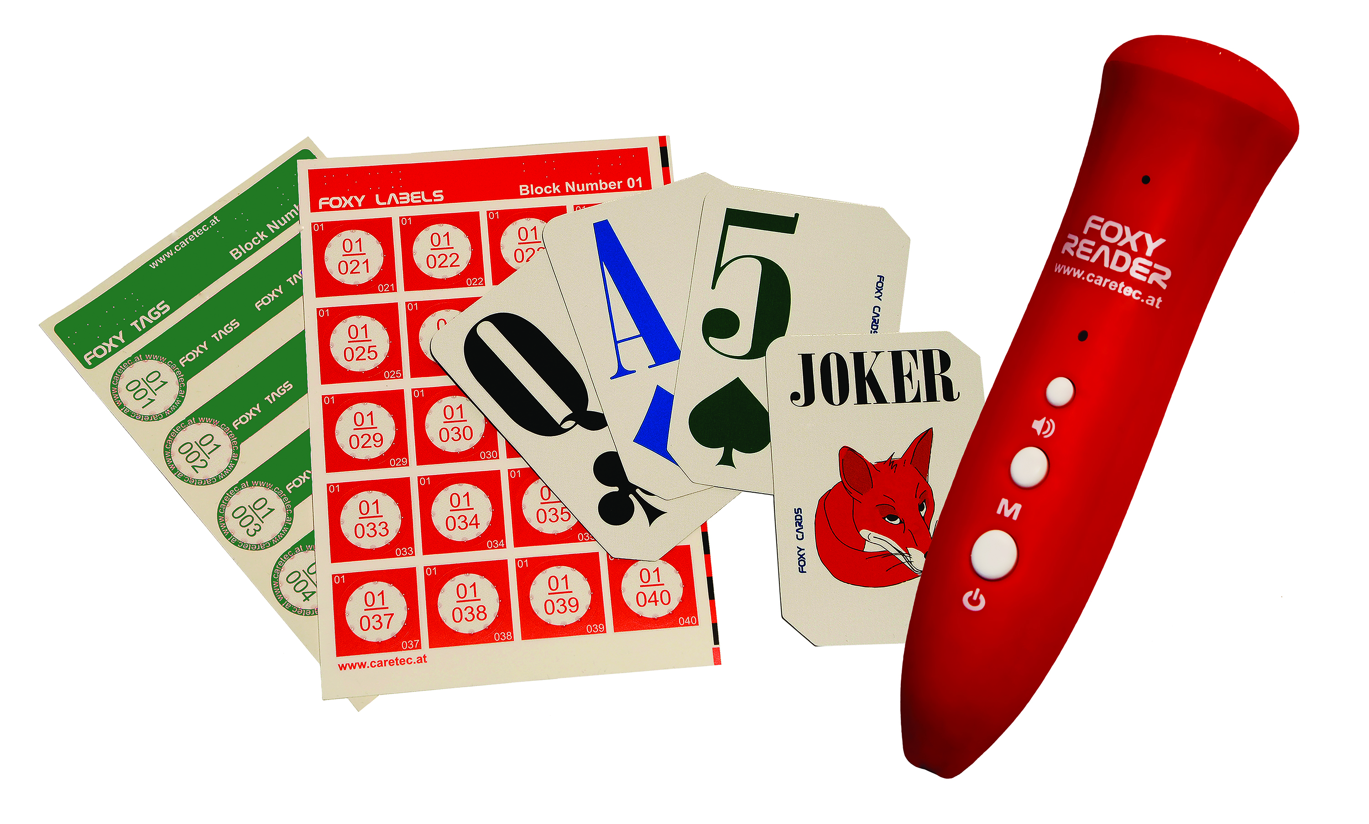


DE EN

Table of Contents

1. Introduction 3

2. Main application area of the Foxy-Reader 3

3. Miscellaneous information 3

4. Description of the device 3

5. Switch on the Foxy-Reader 5

6. Switch off the Foxy-Reader 5

7. Volume control 5

8. Record the label 5

9. Listen to product information 5

10. Recorder 6

11. MP3-Player 6

12. Foxy-Labels 7

13. Foxy-Tags 7

14. Foxy-Cards 7

15. Guarantee and Service 8

16. Cleaning and care 8

17. Producer 8



CARETEC INTERNATIONAL GmbH in Vienna has been developing talking and tactile tools of high quality for blind, visually impaired, deaf-blind and colour-blind people since 1988. These are high-tech products, as well as basic technical aids. CareTec has been awarded with prestigious national and international awards, for example the Winston Gordon Award of the Canadian blind association, the unofficial Nobel Prize of the blind aids industry.

1. Introduction

The Foxy-Reader is able to read small invisible codes. Each entry is dedicated to a code on a particular label as well as one the device.
To record new product information with the device, simply bring the device in contact with the label assigned to the particular product. The code on the label is aligned with a code in the data bank of the Foxy-Reader. When this has been validated acoustically, new product information can be recorded verbally and is saved automatically.

When searching for a particular product later on, simply touch the Foxy-Label on the stored product with the device. The saved product information is announced over the loudspeaker or earphones. To find a specific object several queries are needed. If a label isn’t needed for an object anymore, it can be used for another object and the information can easily be overwritten. Over 60.000 options are possible when tagging an object with labels and tags, or recording a note on the cards. The recording can be as long as you need. The recording capacity is 546 hours (22 days).

2. Main application area of the Foxy-Reader

Easily find and differentiate stored consumer and durable goods and their packaging. To play with special playing cards which are printed with codes on both sides, these cards can be identified from both sides and its information given out via earphones. The Foxy-Reader can also be used as a recorder and MP3-Player.

3. Miscellaneous information

3.1 Content delivery: Foxy-Reader comes with a loudspeaker, a microphone, an earphone socket, 1 SD-memory card with 8 GB (optionally expandable to 32 GB), a mini-USB-cable, a battery charger, earphones, 2 rechargeable batteries 1,2V NiMH, a lanyard, 240 waterproof plastic labels with tactile markings (block-01), 5 Foxy-Tags to fix on clothes, 1 deck of playing cards for blind, visually impaired and seeing players, an user manual in normal print and on CD, a carton box (For storage of the Foxy-Reader and other supplies.)

3.2 Security advice: The device is exceptionally precise. If you’re in any doubt about the accuracy of a recording, repeat the readout – especially with medicine. Prevent the Foxy-Reader to come into contact with water, do not directly expose it to sunlight and store it in a dry area.

3.3 Charging the battery: The device is supplied with 2 rechargeable batteries. Charge the batteries completely with the battery charger before the first use. The total charging time is 2-3 hours. The end of the charging time is indicated by 2 signal tones.


WARNING: Make sure to replace the batteries only with rechargeable ones. Although the device can operate using non-rechargeable batteries, it is not recommended and the user is responsible for preventing the use of a charger in such case.

4. Description of the device

Hold the Foxy-Reader in an upright position so that the tip points downwards and the buttons are facing towards you.

The device components from top to bottom are:
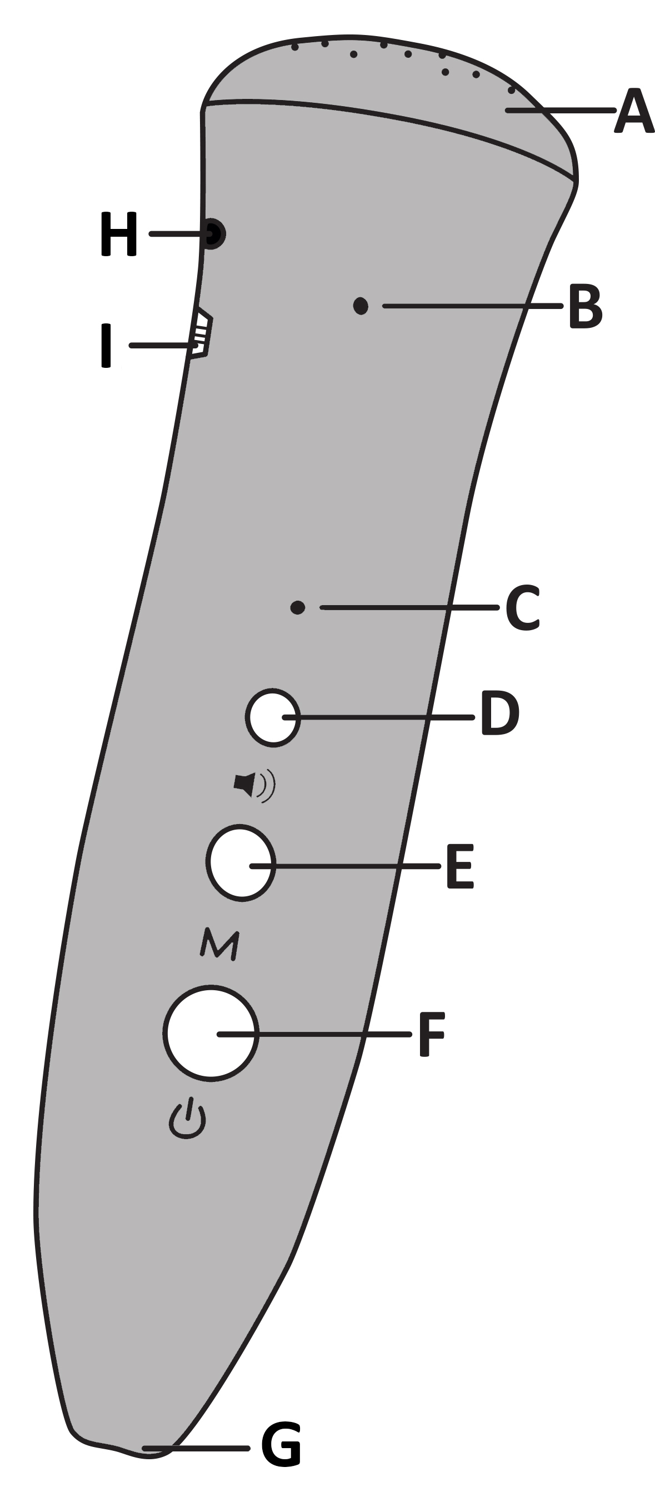
A Loudspeaker at the top of the device.
B Microphone about 2.5 cm below the loudspeaker.
C Light diode about 2.5 cm below the Microphone.
- Diode isn’t flashing, when the device if off.
- Diode flashes blue, when the device is in use.
- Diode flashes briefly in red, the moment
the device is being connected to the computer.
- Diode flashes in purple, when the device
is already connected to the computer.
D Smallest key on the top:
volume control (in 5 levels).
E Medium key in the middle: M-key
(modus-key; recording the information).
F Biggest key at the bottom:
on-/off-key, set of functions.
G Sensor for identifying codes
on the tip of the device.

Two outlets on the left side of the device:
H Earphone socket below the loudspeaker.
I Mini-USB-interface 1 cm below the earphone socket.

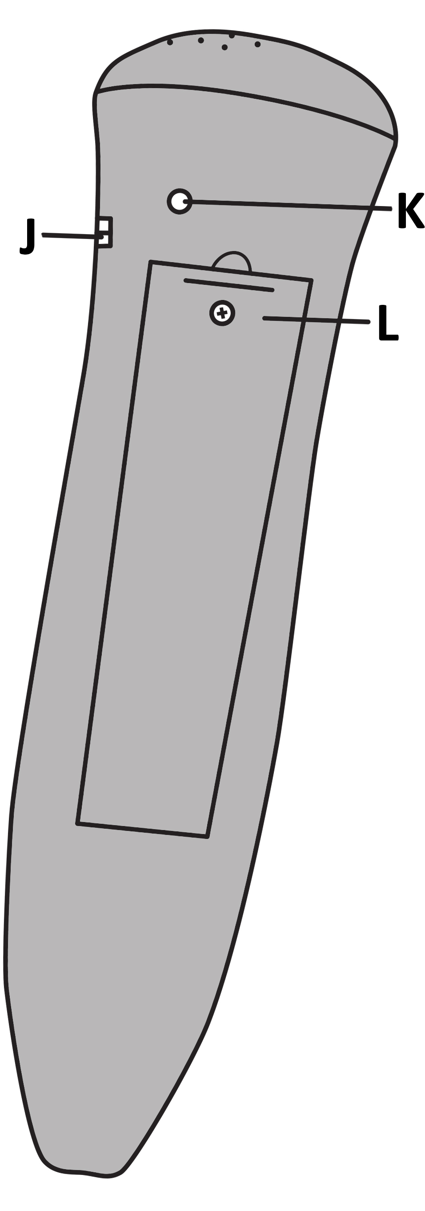
An indent on the right side of the device:
J Connection for the lanyard 2 cm below the loudspeaker.

Two components on the back of the device:
K Screw access to the loudspeaker compartment
1.5 cm below the loudspeaker.
L Battery compartment 2-3 cm below the loudspeaker.

5. Switch on the Foxy-Reader
Hold the on-/off-key (F) for 2-3 seconds. Release the key and wait until rising tones have sounded and ended. The device is ready to be used, when an individual tone resounds. The light diode (C) flashes blue. The device is now ready to retrieve product information.

6. Switch off the Foxy-Reader
Hold the on-/off-key (F) for 2-3 seconds and then release the key. Wait until descending tones have sounded and ended. The device is now switched off, shown by the non-flashing diode (C).

INDICATION: If the device isn’t used for 5 minutes, it switches off automatically, indicated by a descending melody.

7. Volume control

Press volume button (D) briefly to set the volume. 5 volume levels are adjustable. The volume remains at the chosen level until it is raised or lowered.

8. Record the label

8.1 Press M-key (E) and hold it for the next steps:
- Put the tip of the device on a label and wait until you hear the first beep.
- To record something, bring the microphone close to your mouth (10-20 cm distance).
- Speak the product information into the microphone (for any length of time).
- Release the M-key (E) to stop the recording.
8.2 Any information can be overwritten later on. So this process can be repeated again and again.

9. Listen to product information
Touch the label with the tip of the device. Your recording will be automatically played over the loudspeaker or the earphones. To pause push the M-key (E) briefly. By doing this the saved message won’t be deleted.

10. Recorder
Press on-/off-key (F) consecutively until you hear 2 beeps. The recorder-function is now activated.

10.1 Recording notes:
- Hold M-key (E) until you hear one beep.
- Hold the M-key as you speak your note into the microphone.
- When the M-key is released, the note is finished automatically.

10.2 Listen to the recorded note:
- Pressing the M-key (E) briefly allows you to listen to the note.
- The saved note is automatically deleted when you record a new note.

11. MP3-Player
11.1 Press on-/off-key (F) consecutively until you hear 3 beeps.
The MP3-Player is now on:
- Press the M-key (E) briefly to play music.
- Press the M-key long to play the next music-file.
- Press the M-key briefly again to stop the music.

11.2 Connect the device to the computer via USB-cable:
- When successfully connected to the computer the light diode (C) flashes briefly in red. After which it keeps flashing in purple.
- You will find the drive „A10C(V4)“ on your computer desktop.
- When you open the drive, you’ll find the folders ap4, mp3, rec, record and HELP on the list.
- Copy your MP3-files into the MP3-folder. Note that the Foxy-Reader isn’t able to read any file that is saved in a subfolder. So make sure you copy the MP3-files directly into the MP3-folder.
- Switch on the Foxy-Reader and select the MP3-Player. The Foxy-Reader plays the first file from the MP3-folder.

11.3 Listen to the acoustic user manual: Hold the volume key (D) for 2 seconds.

12. Foxy-Labels

Foxy-Labels are water resistant self-adhesive labels with tactile markings and a diameter of 20 mm. You can stick them on products and packaging. The tactile markings help blind people to locate them with their fingers.
There are 20 labels per plastic sheet, which is a little bit smaller than A6. They are arranged in 4 columns and 5 rows. Twelve of the plastic sheets form a block with 240 numbered labels. Block-01 with the numbers 001-240 is included in the purchased package.
INDICATION: When ordering further blocks with 240 labels, please make sure to order a block with subsequent numbers.

13. Foxy-Tags

Foxy-Tags are self-adhesive labels, which can be attached on material loops, found on clothes. The tags are composed of 2 round labels (like the Foxy-Labels), which are connected by a stripe. There are 5 tags on a plastic sheet (block) which are included in the purchased package.
INDICATION: When ordering further tags, please make sure to order blocks with subsequent numbers.

14. Foxy-Cards

These playing cards are completely covered with OID codes, which are invisible to the naked eye. But they can be identified by the Foxy-Reader at any point on the cards and the information can be given to the player discretely via earphones. The cards can also be easily identified from the back when they are lying face down on the table.
Foxy-Cards consist of 52 worldwide used playing cards, marked with 2, 3, 4, 5, 6, 7, 8, 9, 10, Jack, Queen, King, Ace in the suits Hearts, Diamonds, Clubs and Spades, plus 4 Jokers. They are printed with large fonts in 4 different colours, so that visually impaired people can play with them. Two diagonally opposite bevelled corners ease the haptic collecting, stacking, mixing, dealing and handling of the cards.

15. Warranty and service
From the date of purchase, we issue to the original purchase of this product a guarantee of: 24 months on the device itself, 12 months on the accessories (e.g. power supply, earphones etc.), 6 months on wear parts (e.g. battery, case etc.). Please note that we do not issue any guarantee on CDs and memory cards.
During the guarantee periods mentioned above, the product will be either repaired or replaced free of charge. In no event shall CareTec International be liable for indirect, special or consequential damages. The exposure of the device to liquids, strong electromagnetic fields, heat as well as dropping the device or opening the case (expect the battery compartment) causes immediate loss of guarantee. In the event of problems please contact CareTec International or your local distributor before returning the device. We will then inform you about the necessary procedures. The device may only be opened by authorized technicians. CareTec International reserves the right to make any changes or improvements to its products without further notice.

16. Cleaning and care
Clean the surfaces of the Foxy-Reader with a damp cloth. Do not use corrosive and abrasive cleaning products. Don’t scrub the surface with rough objects (not even sponges).

17. Producer

 | This device was produced by  CareTec International GmbH  Stubenbastei 1, 1010 Vienna, Austria.  Tel: (+43 1) 5138081-0; Fax: (+43 1) 5138081-9;  E-mail: office@caretec.at; Web: www.caretec.at

Foxy Reader V1.1 06/2025

